Assets list

The art style if going to be a cartoonish style.

All this assets are not final, they are just an idea of what the game can be like.

**The icons that are going to be used in the user interface**

Asset info:

Title: 140 Military Icons Set

Author: AngryMeteor.com

Created: 31, July 2015

Price: free

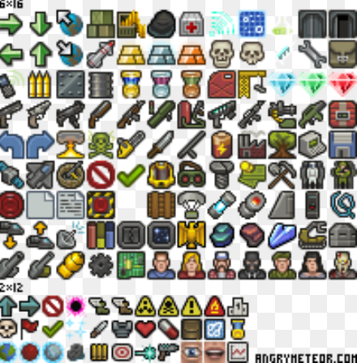

Image retrived from <https://opengameart.org/content/140-military-icons-set-fixed> at 24/01/2018

**Example one of the vehicle present in the game:**

Asset info:

Title: Humvee Isometric

Author: Stagnation

Created: 25, June 2015

Price: free

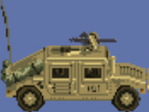

Image retrieved from <https://opengameart.org/content/humvee-isometric> at 24/01/2018

**Example one of another vehicle present in the game:**

Asset info:

Title: Military Jeep

Author: yd

Created: 28, October 2012

Price: free

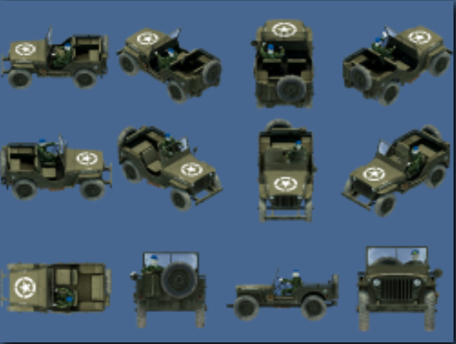

Image retrieved from <https://opengameart.org/content/military-jeep> at 24/01/2018

**Example one of the helicopter present in the game:**

Asset info:

Title: Attack Helicopter

Author: GameDeveloperStudio

Price: 0.95

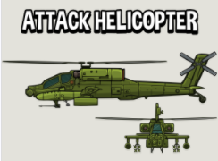

Image retrieved from <https://www.gamedeveloperstudio.com/graphics/viewgraphic.php?item=1x4y9w1y5n041e3g9s> at 24/01/2018

**Example of the game background**

Asset info:

This is a mere example how to game is going to look like.

